|  |  |
| --- | --- |
| **Team Color:** | **Brown** |
| **Preferred Team Name:** | Brown Brown |
| **Team Members with Contact Info:** | Peter Bordush bordushp@mymacewan.ca  Bruce Leung leungb6@mymacewan.ca  Terry Youngman youngmant@mymacewan.ca  Michael Zhao zhaom5@mymacewa.ca |
| **Platform/Tools Used** (this should include what each is being used for, where to go to get the data and documentation and any other relevant information) | Node.js version 8.94 LTS for server. MySQL for database on backend. Vue, Vuetify, Express for frontend. Installation instructions are in the README.txt file. |
| **Product Backlog and all other documents are in the attached folder.** | Contained with this submission. |
| **Git location:** | <https://github.com/macewanCS/w18brown> |

# Sprint 1

**Sprint Planning Meeting:**

Attendees: All members were present.

Goal:

* In the first sprint, the primary obstacle is to overcome a lack of experience with web development. Our goal is to learn these skills and demonstrate our success by completing all sprint backlog stories. These are stories 1-12.

Commitment Levels:

* The team has a high commitment level. All members would like our software to be deployed. However, time commitments are limited.

Sprint length & Velocity:

* Sprint length is 3 weeks. Estimated velocity is 60.5 hours.
* Calculations are based on simple resource calculations. Focus factor is based on a minimum commitment estimate of 5 hours of productive time per member per week.
* Available person days = 60. Focus factor = 0.042. Estimated velocity = available person days * focus factor = 60 days * 0.042 = 2.5 days = 60.5 hours.

Sprint Backlog:

* See screenshots below in this document for the state of the backlog in weekly intervals or the attached file “395BrownSprint1” which is up to date for the end of the sprint but provides a larger view.

Time & Place for daily scrum:

* The scrum meeting will be held at the beginning of the Tuesday lab at 2pm.
* Scrum meetings will also be held at the end of Wednesday or Friday classes at 2pm.

Notes:

* Many tasks are checked out and performed outside of official meetings. These are tracked on the sprint pages.
* Work will be divided by role rather than by stories.
  + Peter will be working on the back end and focusing on the database.
  + Bruce will be working on the front end HTML and CSS.
  + Terry will be working on the back end but focusing on sprint documentation.
  + Michael will be working on the front end HTML and CSS.

**Meeting 0.1: 2018/01/12**

Meeting Attendees: All

Goal: Discuss the project, software options, commitment levels.

Notes: We would research platforms - ASP.NET Core and Node.js are the competing platforms. Bruce and Michael agreed to work on the web design with Terry and Peter agreeing to work on the database / backend.

**Meeting 0.2: 2018/1/16**

Meeting Attendees: All

Goal: Complete backlog. Discuss potential problems.

Notes: We agreed to use Node.js for our platform. Also discussed the idea of using a calendar API to keep track of booking logic. Google Calendar was briefly looked into. We will revisit that during the first Sprint.

**Meeting 1.1: 2018/01/19**

Meeting Attendees: All

Goal: Discuss first steps. Layout for first sprint pages.

Notes: First objective is to create the admin login portion of the site from database to web page.

**Meeting 1.2: 2018/1/23**

Meeting Attendees: Bruce, Terry, Peter

Goal: Plan database tables in excel. HTML for login page. Make as much progress on login full stack as possible.

Notes: Database planning completed with 15 tables in total. Html file for login created.

**Week 1 Sprint Backlog**

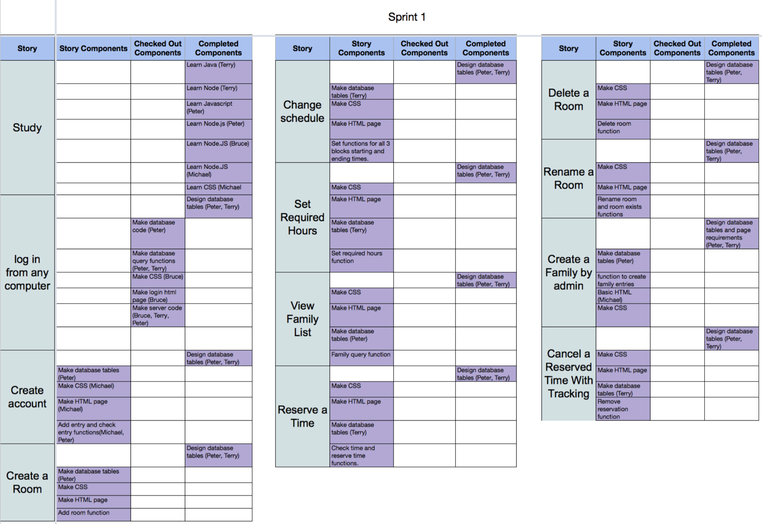

**Meeting 1.3: 2018/2/2**

Meeting Attendees: Peter, Bruce, Terry

Goal: Document database functions. Plan page transitions. Plan work for tomorrow.

Notes: Terry will do settings table. Peter will do facilitator and room table. Bruce will update CSS files.

**Week 2 Sprint Backlog**

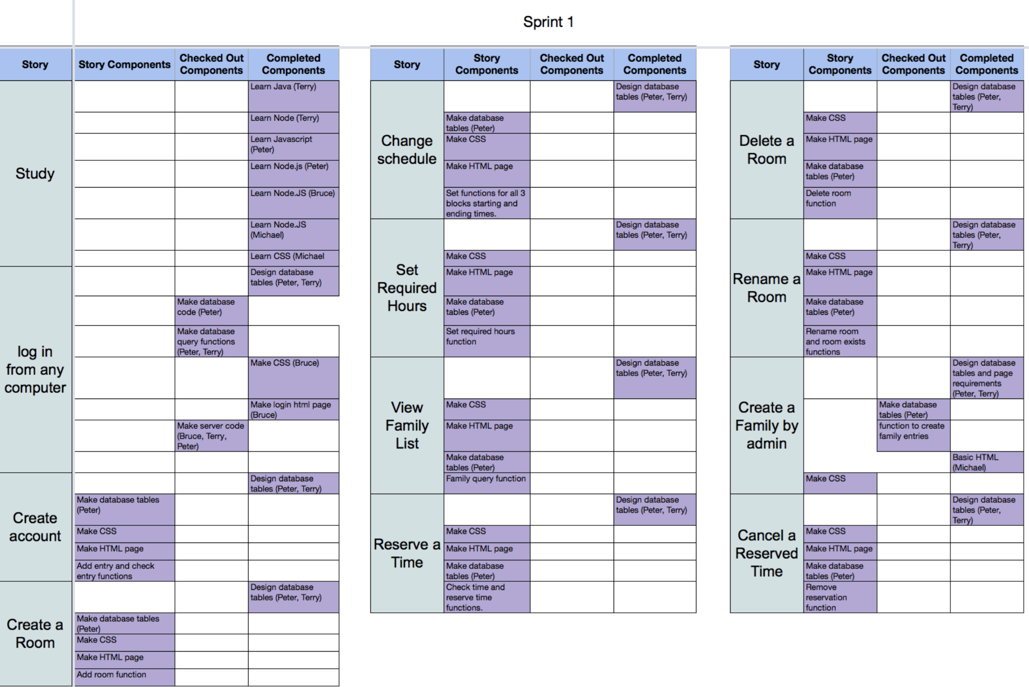

**Meeting 2018/2/6:**

Meeting Attendees: All

Goal: Peter and Terry did pair programming for queries and required functions for this sprint. Terry will read more scrum and update documents including test requirements, how to demo, burndown chart, and priority/estimate on sprint backlog. Peter will solve the async issue. Peter will finish database construction and upload to shared drive tonight and test logins. Bruce and Michael designed layouts for room management and reserve time tracking pages. Bruce and Michael also discussed how to implement Ajax in connecting the auxiliary pages to the main admin page.

Notes: Mockups also need to be made.

**Meeting 2018/2/9:**

Meeting Attendees: Bruce, Terry

Goal: Plan to add feedback for failed login. Decided that the reserve and cancel time stories should be left for last and to focus on completing stories that are closer to completed. Talked about site wide and individual page CSS. Went over demo requirements.

Notes: Peter is sick and Michael has a family emergency but did communicate with the team with discord. Testing and Integration tasks have been added to stories after realizing that these tasks were being overlooked.

**Week 3 Sprint Backlog**

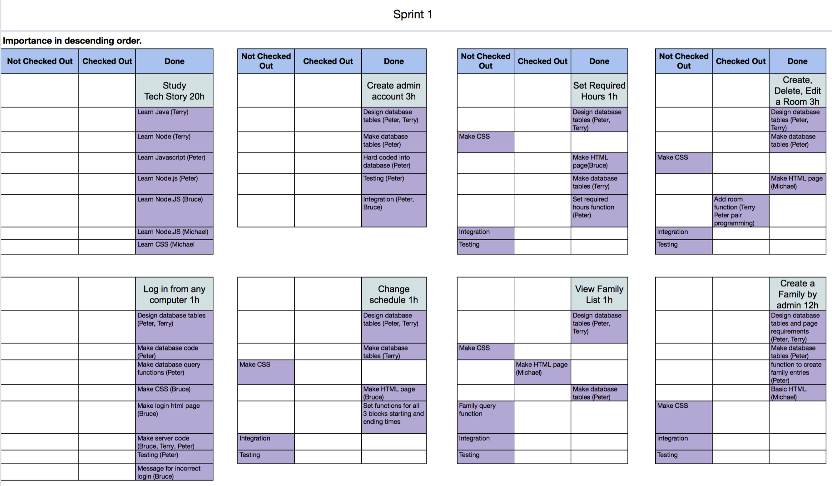

**Meeting 2018/2/13:**

Meeting Attendees: Terry, Peter, Bruce

Goal: Practice the demo.

Notes: Michael had a lab at the time and was unable to attend.

**Demo 1 - 2018/2/13:**

Stories to demo: Log in, Show admin login, partial stories for change schedule, set required hours, create delete and edit rooms, and create a family.

Attendees: All group Brown members. Stephanie. Various students.

Notes: We became aware of the need for a master test document.

**Retrospective 2018/2/16:**

Meeting Attendees: All

Goal: Discuss what was done well, could have been better and what points to improve on in the future.

Notes: We decided the vote for improvements rather than using a limited number of tokens because the improvement goals could all potentially be achievable.

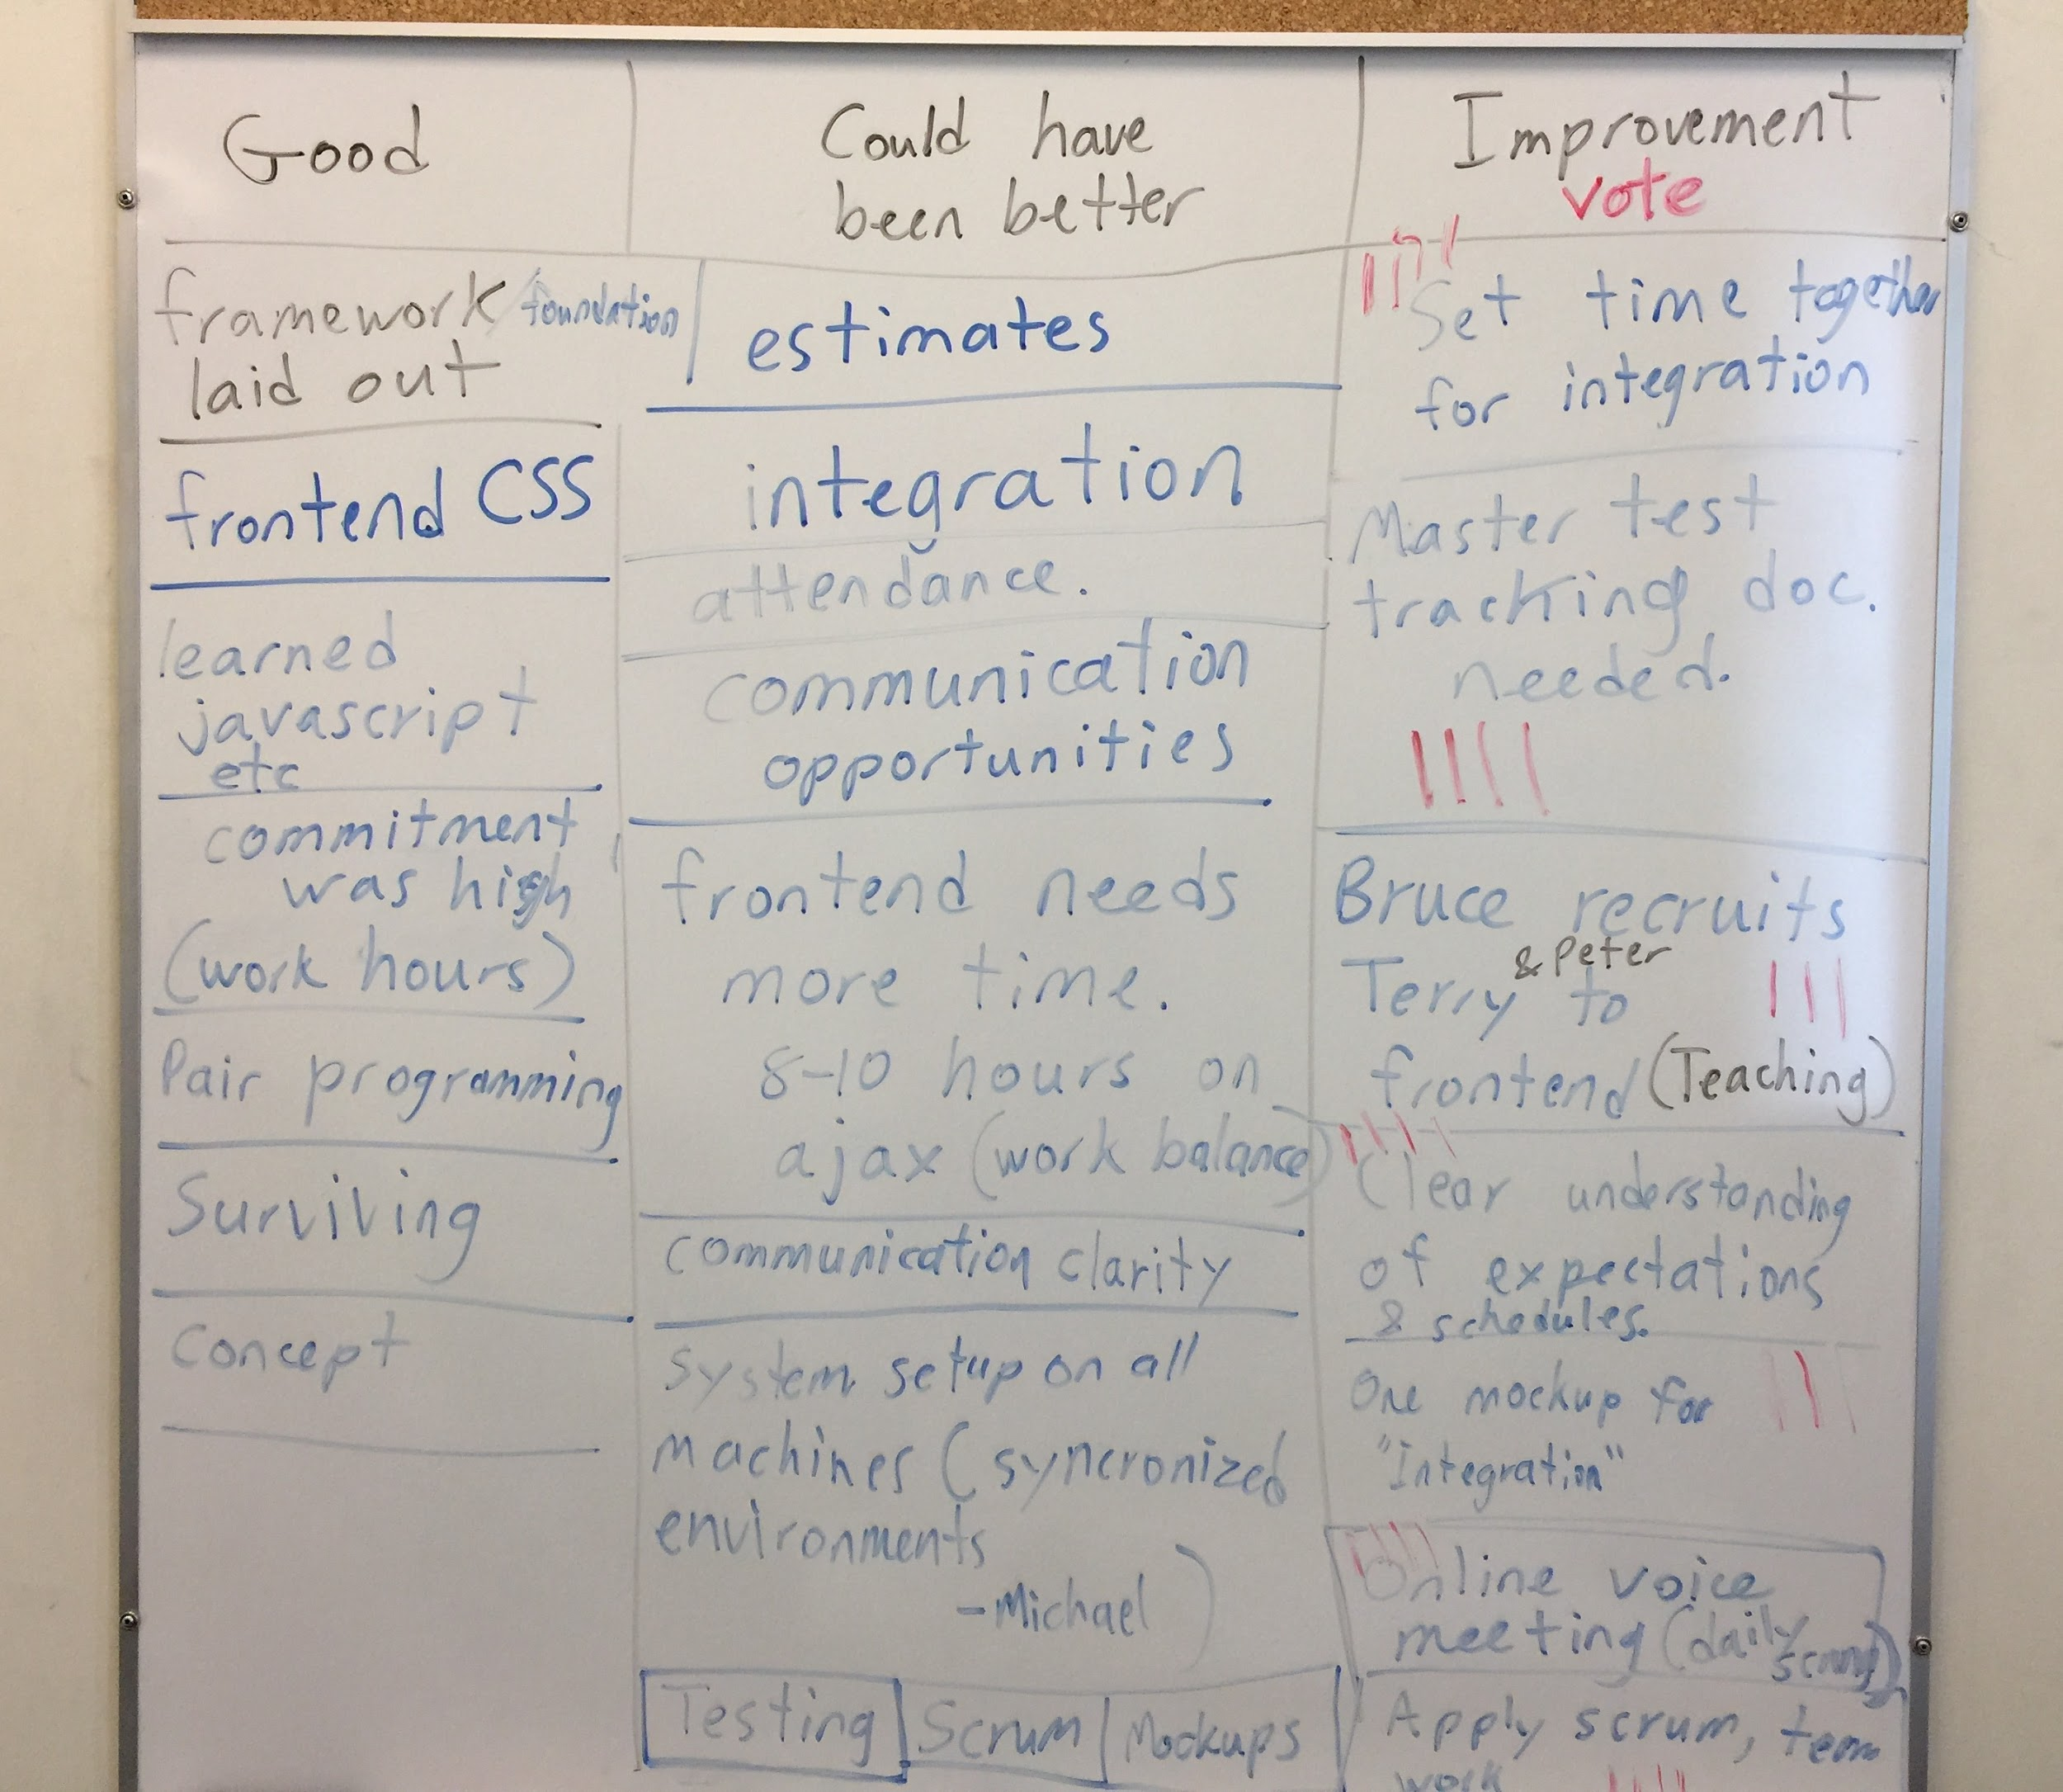

Plans:

* To improve, the team has agreed to scheduled team meetings and work periods.
  + Over reading week: Feb 21st, 9:30 - 4:00 and potentially on Feb 23rd as well.
  + Weekly: Fridays from 2:00 - 6:00 including a scrum meeting and work period.
  + Voice chat meeting: Sunday at 1:00 pm including a scrum meeting followed by individual work.
  + In case lab time is unavailable, we will meet on Sunday to make up the lost time.
* Having more work time will help with software integration, teaching each other, clarifying work expectations and allowing for scrum practices.
* The master tracking document will be created when we have enough integration to start testing. Unit testing code is currently underdeveloped.
* The value of the mockup is not very high in the team. Some members are willing to do one mockup (in total) to see if it helps communicate design ideas. The low value on the mockup is due to a lack of CSS experience and a sense that we may not be able to realize the goal. Mockups and CSS may need to revisited in the future once more critical components are functional.
* It was decided to extend sprint 1 to include reading week rather than starting sprint 2 early. This is due to the number of incomplete stories that we would like to complete before moving on.

**Burndown for Sprint 1 on 2018/2/16:**

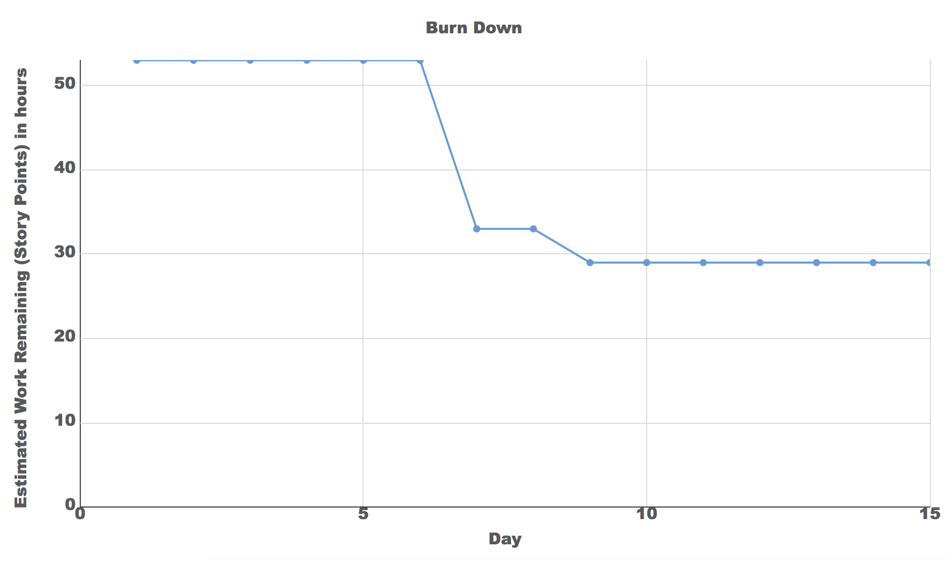

Note: The first week of the sprint was used for learning time.

**Meeting 2018/02/21:**

Meeting Attendees: Bruce, Terry

Goal: Get mysql working on Terry’s mac (successful). Learn more about mysql commands. Put mysql instructions in a readme file on git. Refactor to include vue.js.

**Meeting 2018/02/22:**

Meeting Attendees: All

Goal: Set up mysql on all machines. Refactor vue for rooms page. Setup software for back end unit testing. Start learning vuetify. Room page integration. Setup package.json. Merge code. Add roomID to room table.

**Sprint 1 backlog at the end of sprint 1 on 2018/02/26:**

Note: The sprint was extended over reading week, past the retrospective. This time was used to change the front end to use Vue, add a routing system and split the front and back and servers.

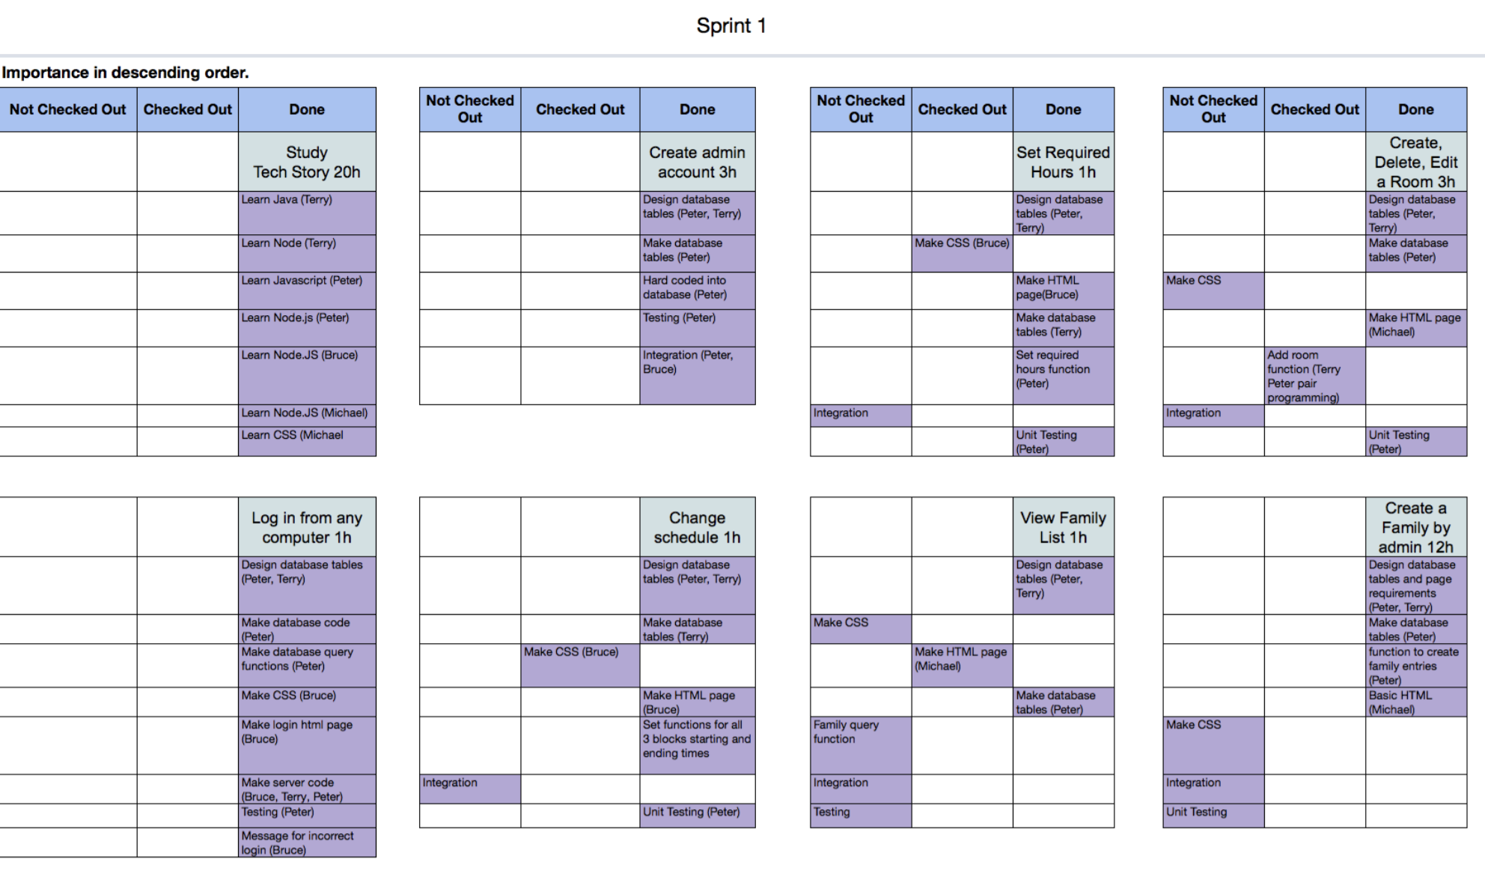

# Sprint 2

**Sprint 2 Sprint Planning Meeting on 2018/02/27:**

Attendees: All members were present.

Goal:

* In the second sprint, we plan to incorporate scrum practices into our work. We also plan to complete the sprint with a good demo. This will be accomplished by completing the admin tasks with a focus on quality.

Commitment Levels:

* Bruce is willing to sacrifice his marks for the project. A true martyr. Peter’s commitment level has increased. Terry and Michael will have higher commitment levels starting in the 2nd week of this sprint after midterms.

Sprint length & Velocity:

* Note: We will be creating new estimates with increased commitment levels rather than using actual velocity due to the large errors in our previous estimates.
* Sprint length is 3 weeks. Estimated velocity is 108 hours.
* Calculations are based on simple resource calculations. Focus factor is based on a minimum commitment estimate of 9 hours of productive time per member per week.
* Available person days = 60. Focus factor = 0.075. Estimated velocity = available person days * focus factor = 60 days * 0.075 = 4.5 days = 108 hours.

Sprint Backlog:

* See screenshots below in this document for the state of the backlog in weekly intervals or the attached file “395BrownSprint2”.

Time & Place for daily scrum:

* Weekly: Fridays from 2:00 - 6:00 including a scrum meeting and work period.
* Voice chat meeting: Sunday at 1:00 pm including a scrum meeting followed by individual work.
* In case lab time is unavailable, we will meet on Sunday to make up the lost time.

Notes:

* Many tasks are checked out and performed outside of official meetings. These are tracked on the sprint pages.
* Work will be divided by role rather than by stories.
  + Terry will be moving to the front end and integration.

**Meeting 2018/03/03:**

Meeting Attendees: All

Goal: Login page integration was completed using vue. Added new users to the database for testing. Made routing on frontend and backend to direct users to different pages depending on their account type. Created empty pages for all user types. Created nav bars for all user types. Added room link on admin nav bar. Ate sandwiches. Bruce and Michael did pair programming to learn how to use vue. Made a mockup plan for the family account page.

**Sprint 2 backlog on 2018/03/06:**

Note: There were no changes. We were still refactoring at this time. Although tasks were completed, they were tasks that were previously done in with previous code.



**Meeting 2018/03/06:**

Meeting Attendees: All

Goal: Finished the navigation. Started a page to add staff accounts. Made backend for the staff accounts.

**Meeting 2018/03/09:**

Meeting Attendees: All

Goal: Make function to delete employee. Create list of employees backend. Create a reservation and display backend. Integration for reservations. Finish converting family and rooms to vue and integrate. Create a family backend. Integration for reserve. Fix CSS for reserve. Finish employee integration. Research how to display warnings on frontend.

**Meeting 2018/03/12:**

Meeting Attendees: Terry and Bruce

Goal: CSS decisions made for the calendar, family, settings, and employee account pages.

Notes: Bruce and Terry pair programming. Many tasks were completed over the weekend using discord to communicate including voice calls and screen sharing.

**Meeting 2018/03/13:**

Meeting Attendees: Peter, Bruce and Terry

Goal: Demo practice. Last minute code fixes. Updated the rooms page. Git sync and testing.

Notes: Michael is sick.

**Demo 2 - 2018/03/13:**

Stories to demo: Log in with all user types. Navigation. Create and delete employees. View a list of employees. View rooms. Add rooms. Add family (incomplete) Change settings including block times and start date. Facilitator view calendar and sign up (incomplete).

Attendees: Peter, Bruce, Terry, Stephanie, Karen and various students.

Notes: Feedback notes were taken by Peter and will be incorporated into future plans.

**Sprint 2 backlog on 2018/03/15:**

Note: Set required hours and change schedule stories were merged into one story because they are both part of the same settings page. Both were completed. An epic story for viewing the calendar and making reservations into two stories was broken down into the calendar portion and the reservation portion. The old screenshots were not updated. Unplanned tasks have been added below the grey box. 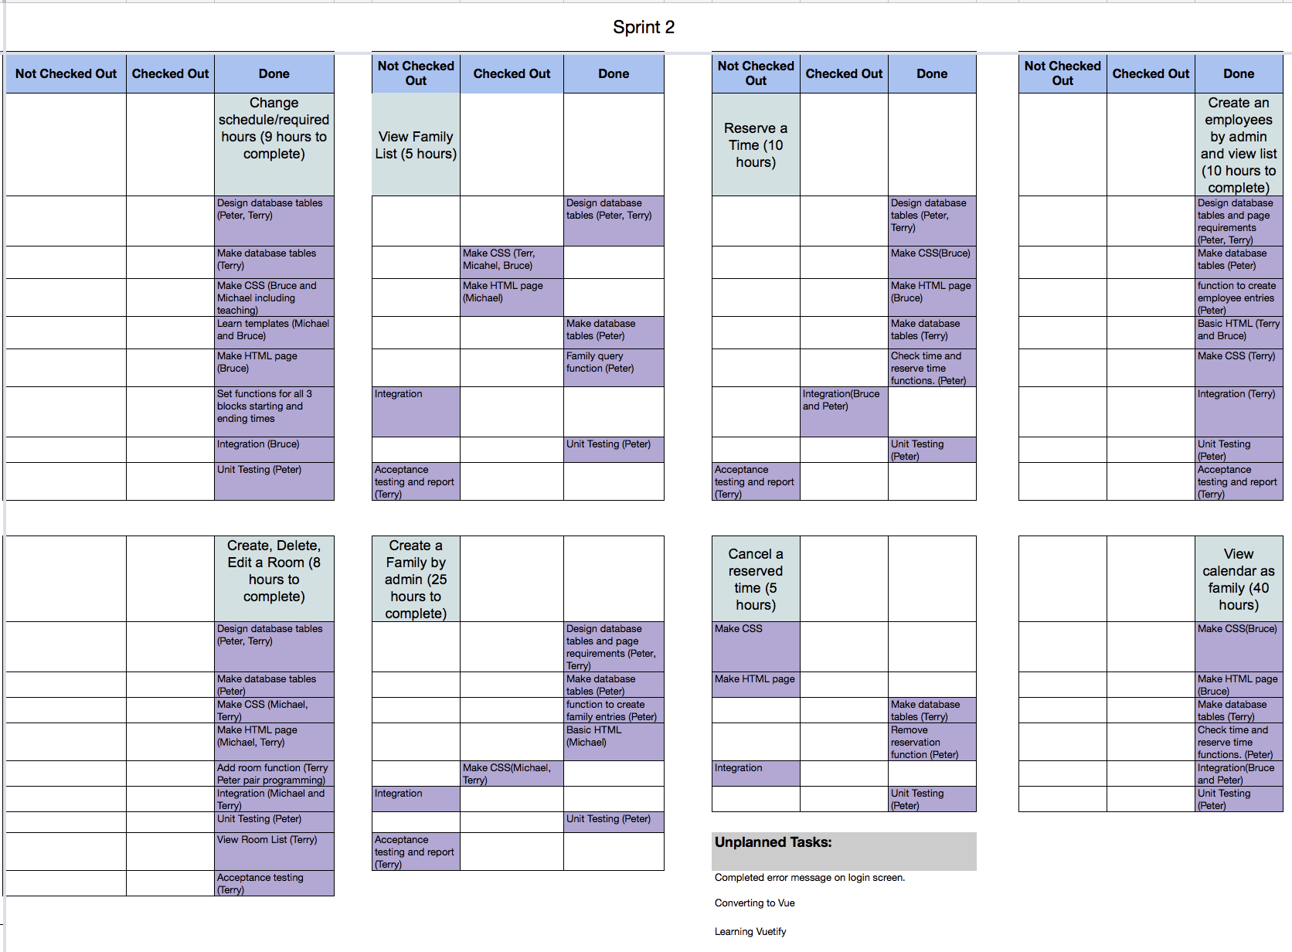

**Meeting 2018/03/18:**

Meeting Attendees: Peter, Bruce, Terry

Goal: Plan meeting time with Taryn. Discuss authentication options. Discuss reservation integration.

Notes: This was a 50 minute voice chat meeting. We found it useful for planning. Bruce and Terry also tried screen sharing recently which was quite useful for debugging.

**Burndown for Spring 2 on 2018/03/18:**

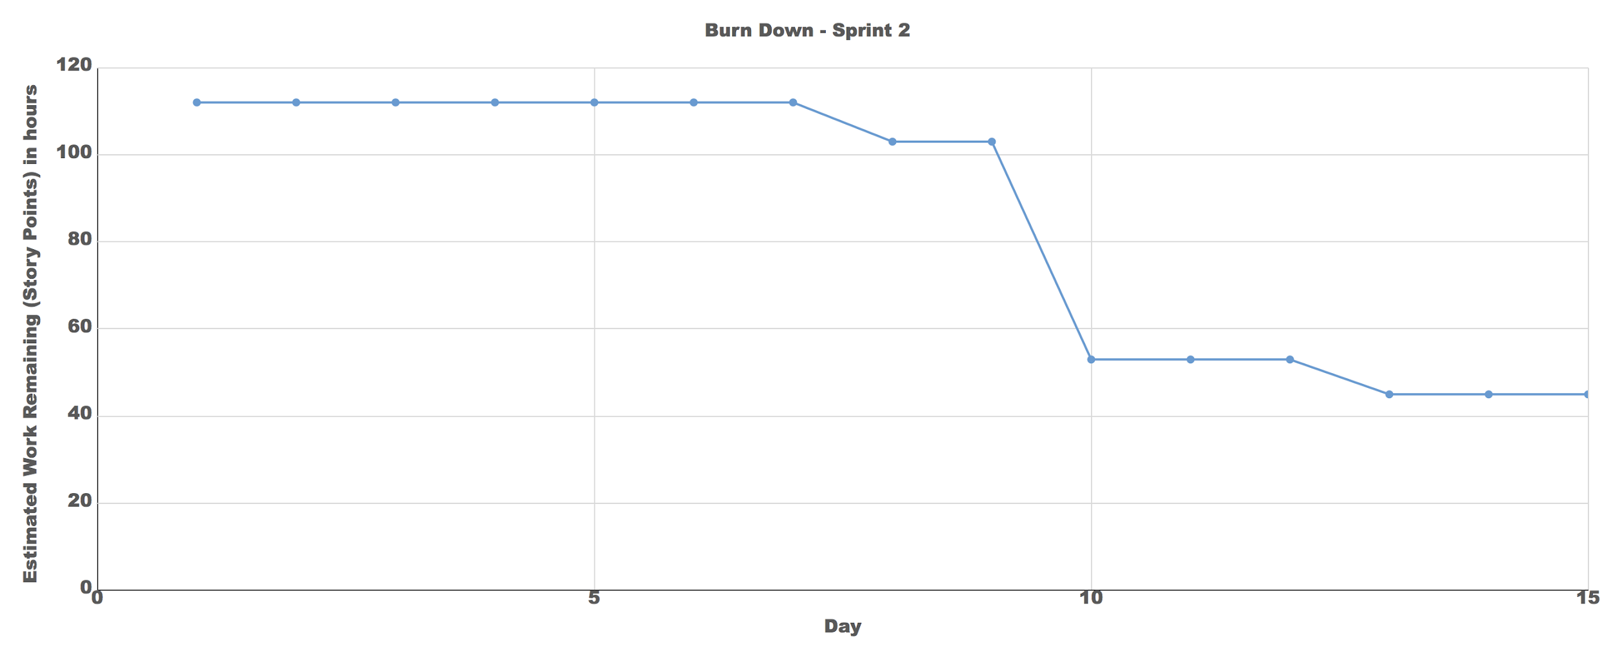

**End of Sprint 2 Backlog on 2018/03/18:**

Note: The only change since the last screenshot is integration on reservations.

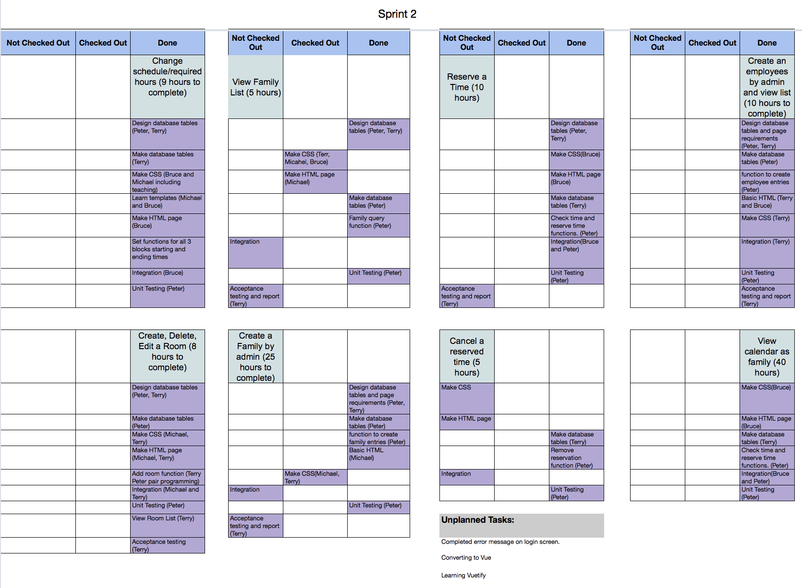

**Retrospective 2018/03/20:**

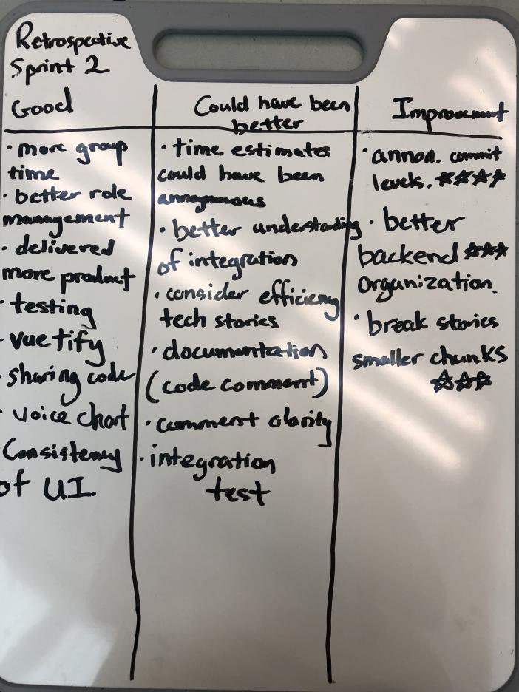

Meeting Attendees: All

Goal: We will be acknowledging that each group member has different commitment levels and schedules. To avoid peer pressure influencing our commitment levels, we will use the planning poker strategy and write our commitment levels before knowing what everyone else is planning. This should allow for more accurate velocities and prevent people from getting overloaded. Some reorganization of the backend files may occur to make it easier to find functions, however, this is low priority.

Notes: This sprint was considerably better than sprint 1. We worked much better as a team thanks to the increased amount of group time, chat, and voice time. We were also much faster with sharing code.

Plans:

* We will be continuing with our current schedule in the next sprint.

# Sprint 3

**Sprint 3 Backlog on 2018/03/19:**

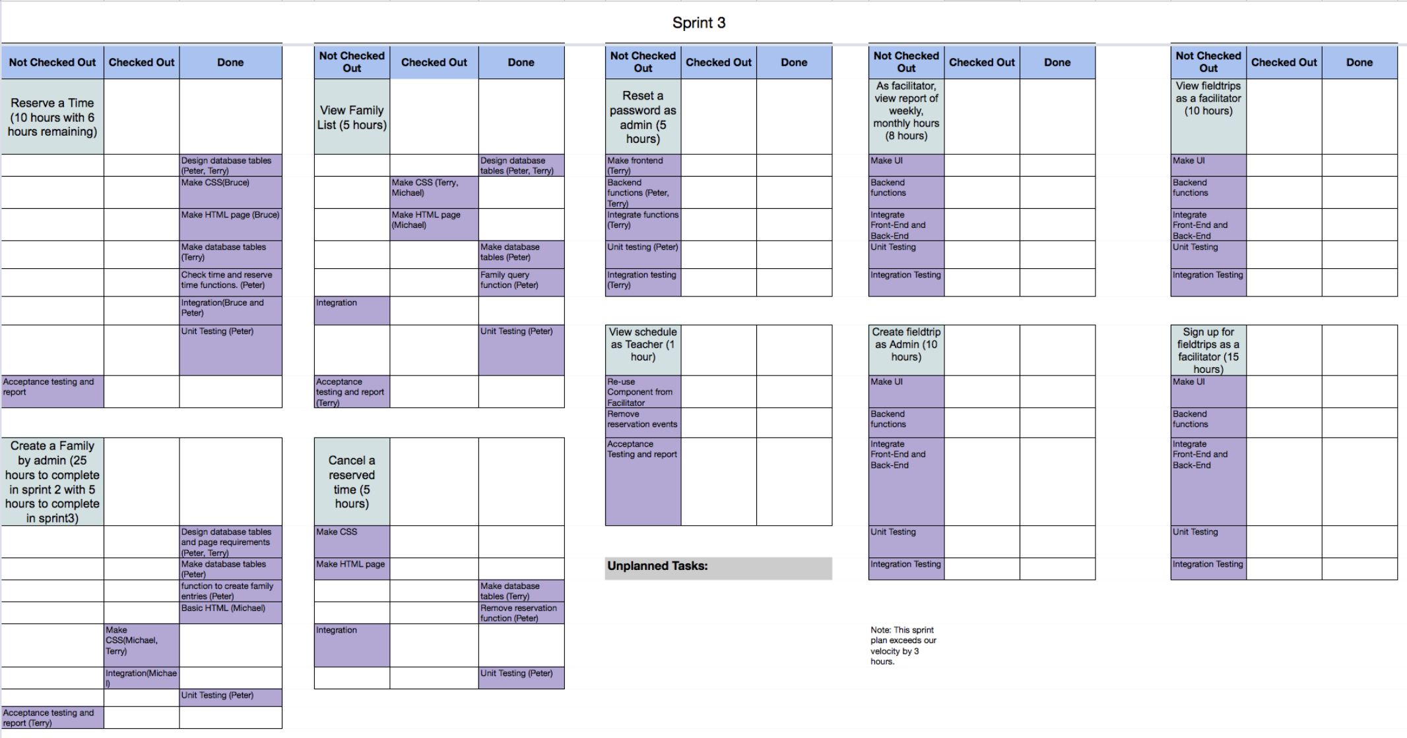

**Sprint Planning Meeting: 2018/03/23**

Attendees: Bruce, Michael and Terry

Goal:

* Complete the happy path for the project. This involves all required functionality.

Commitment Levels:

* We will maintain the same commitment level as in sprint 2.

Sprint length & Velocity:

* Sprint length is 3 weeks. Estimated velocity is 67 hours based on sprint 2 velocity.

Sprint Backlog:

* See screenshots below in this document for the state of the backlog in weekly intervals or the attached file “395BrownSprint3”.

Time & Place for daily scrum:

* The scrum meeting will be held at the beginning of the Tuesday lab at 2pm.
* Scrum meetings will also be held at the end of Wednesday or Friday classes at 2pm.

Notes:

* Many tasks are checked out and performed outside of official meetings. These are tracked on the sprint pages.
* Peter is unavailable due to a family emergency.

**Meeting 2018/03/20:**

Meeting Attendees: All group members and Taryn Laramie from Full Auto Media

Goal: Ask advice from a professional developer. Topics covered included the happy path, a review of our product with advice for improvements, calendar visibility, reducing the payload, auto complete fields, modules, and various stories including the ability for a 4th person to reserve a time slot.

Notes: Many helpful suggestions were made. Not all will be practical to implement in sprint 3 but all of the advice was valuable for our education and will impact future work and projects.

**Sprint 3 backlog on 2018/03/23:**

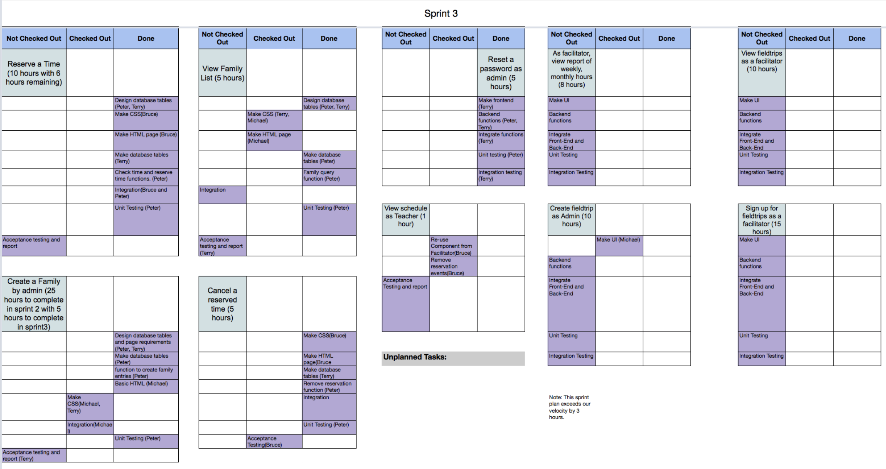

**Meeting 2018/03/27:**

Meeting Attendees: All

Goal: Peter got a list of required functions for the week. Planned earned hours calculations. Planned how to notify users of cancelled reservations. Fix backend family functions. Plan how to pull children information for family accounts. Plan how to deal with field trips.

Notes:

**Meeting 2018/03/28:**

Meeting Attendees: Bruce, Terry, Michael

Goal: This was a class work period. We did not have a lot of time so skipped the scrum meeting. We worked on family integration and required hours for the family dashboard.

**Meeting 2018/03/30:**

Meeting Attendees: Bruce, Terry

Goal: Work on family dashboard frontend, integration and functions. Implement more UI changes for supporting Field Trips, and refactored cancellation of Reservations. Begin implementing authentication system to deny access to pages if the user is not logged in.

Notes: Did some team debugging and teaching.

**Sprint 3 backlog on 2018/03/30:**

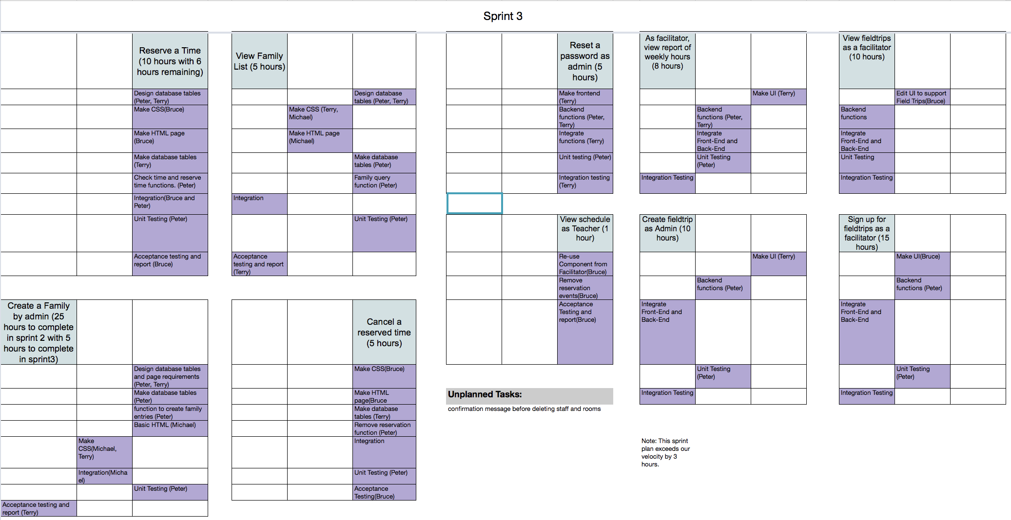

**Meeting 2018/04/03:**

Meeting Attendees: Bruce, Michael, Terry

Goal: Fixed a bug with calendar lists. Debugging family adding and listing code as a team. Testing code before showing it to Stephanie.

Notes: Fixed most of the issues Stephanie pointed out in the lab.

**Meeting 2018/04/04:**

Meeting Attendees: Michael, Terry

Goal: Worked on view family. Removed admin and teacher dashboards. Copied view teacher schedule into view board schedule. Added frontend for required hours.

Notes:

**Meeting 2018/04/06:**

Meeting Attendees: All

Goal: Reviewed plans and what has happened over the last week while Peter was away. Planned changes to table and backend functions for calculating hours earned and required hours. Discussed family error checking.

Notes: Changing our github repository to public broke our forks. We will be correcting the problem.

**Meeting 2018/04/07:**

Meeting Attendees: All

Goal: Fix github forks for everyone. Updated database tables and datatable excel file. Discussed how to format reports. Finish create field trip error checking, integration, confirmation. Making backend for hours earned.

Notes: At Startup Edmonton hack day.

**Meeting 2018/04/08:**

Meeting Attendees: All

Goal: Discuss last changes. Changing database data to prepare for demo. Finalize deliverables. Update documentation.

Notes: Voice chat.

**Meeting 2018/04/09:**

Meeting Attendees: All

Goal: Coordinate presentation tasks and style. Last minute changes and git fixes.

Notes: Created an order of presentation tasks and made sure there were backup computers to demonstrate functionality created.

**Demo 1 - 2018/04/09:**

Stories to demo: All stories were demoed from sprint 1 to 3.

Attendees: All group Brown members. Stephanie. Taryn. Karen. Various students.

Notes: Stories that were almost complete were not demoed. We did lose some integration, apparently in the re-merging process after our git problem. These are just small functions in the app.js file that need to be found, copied, and pasted into place.

**Retrospective 2018/04/09:**

Meeting Attendees: All

Goal: Discuss what was done well, could have been better and what points to improve on in the future.

Notes: We did not vote on improvements because the project is completed. Instead, reflected on the entire project. It was hard to think of points to improve on the retrospective. This shows how much we have improved as a team over the semester.

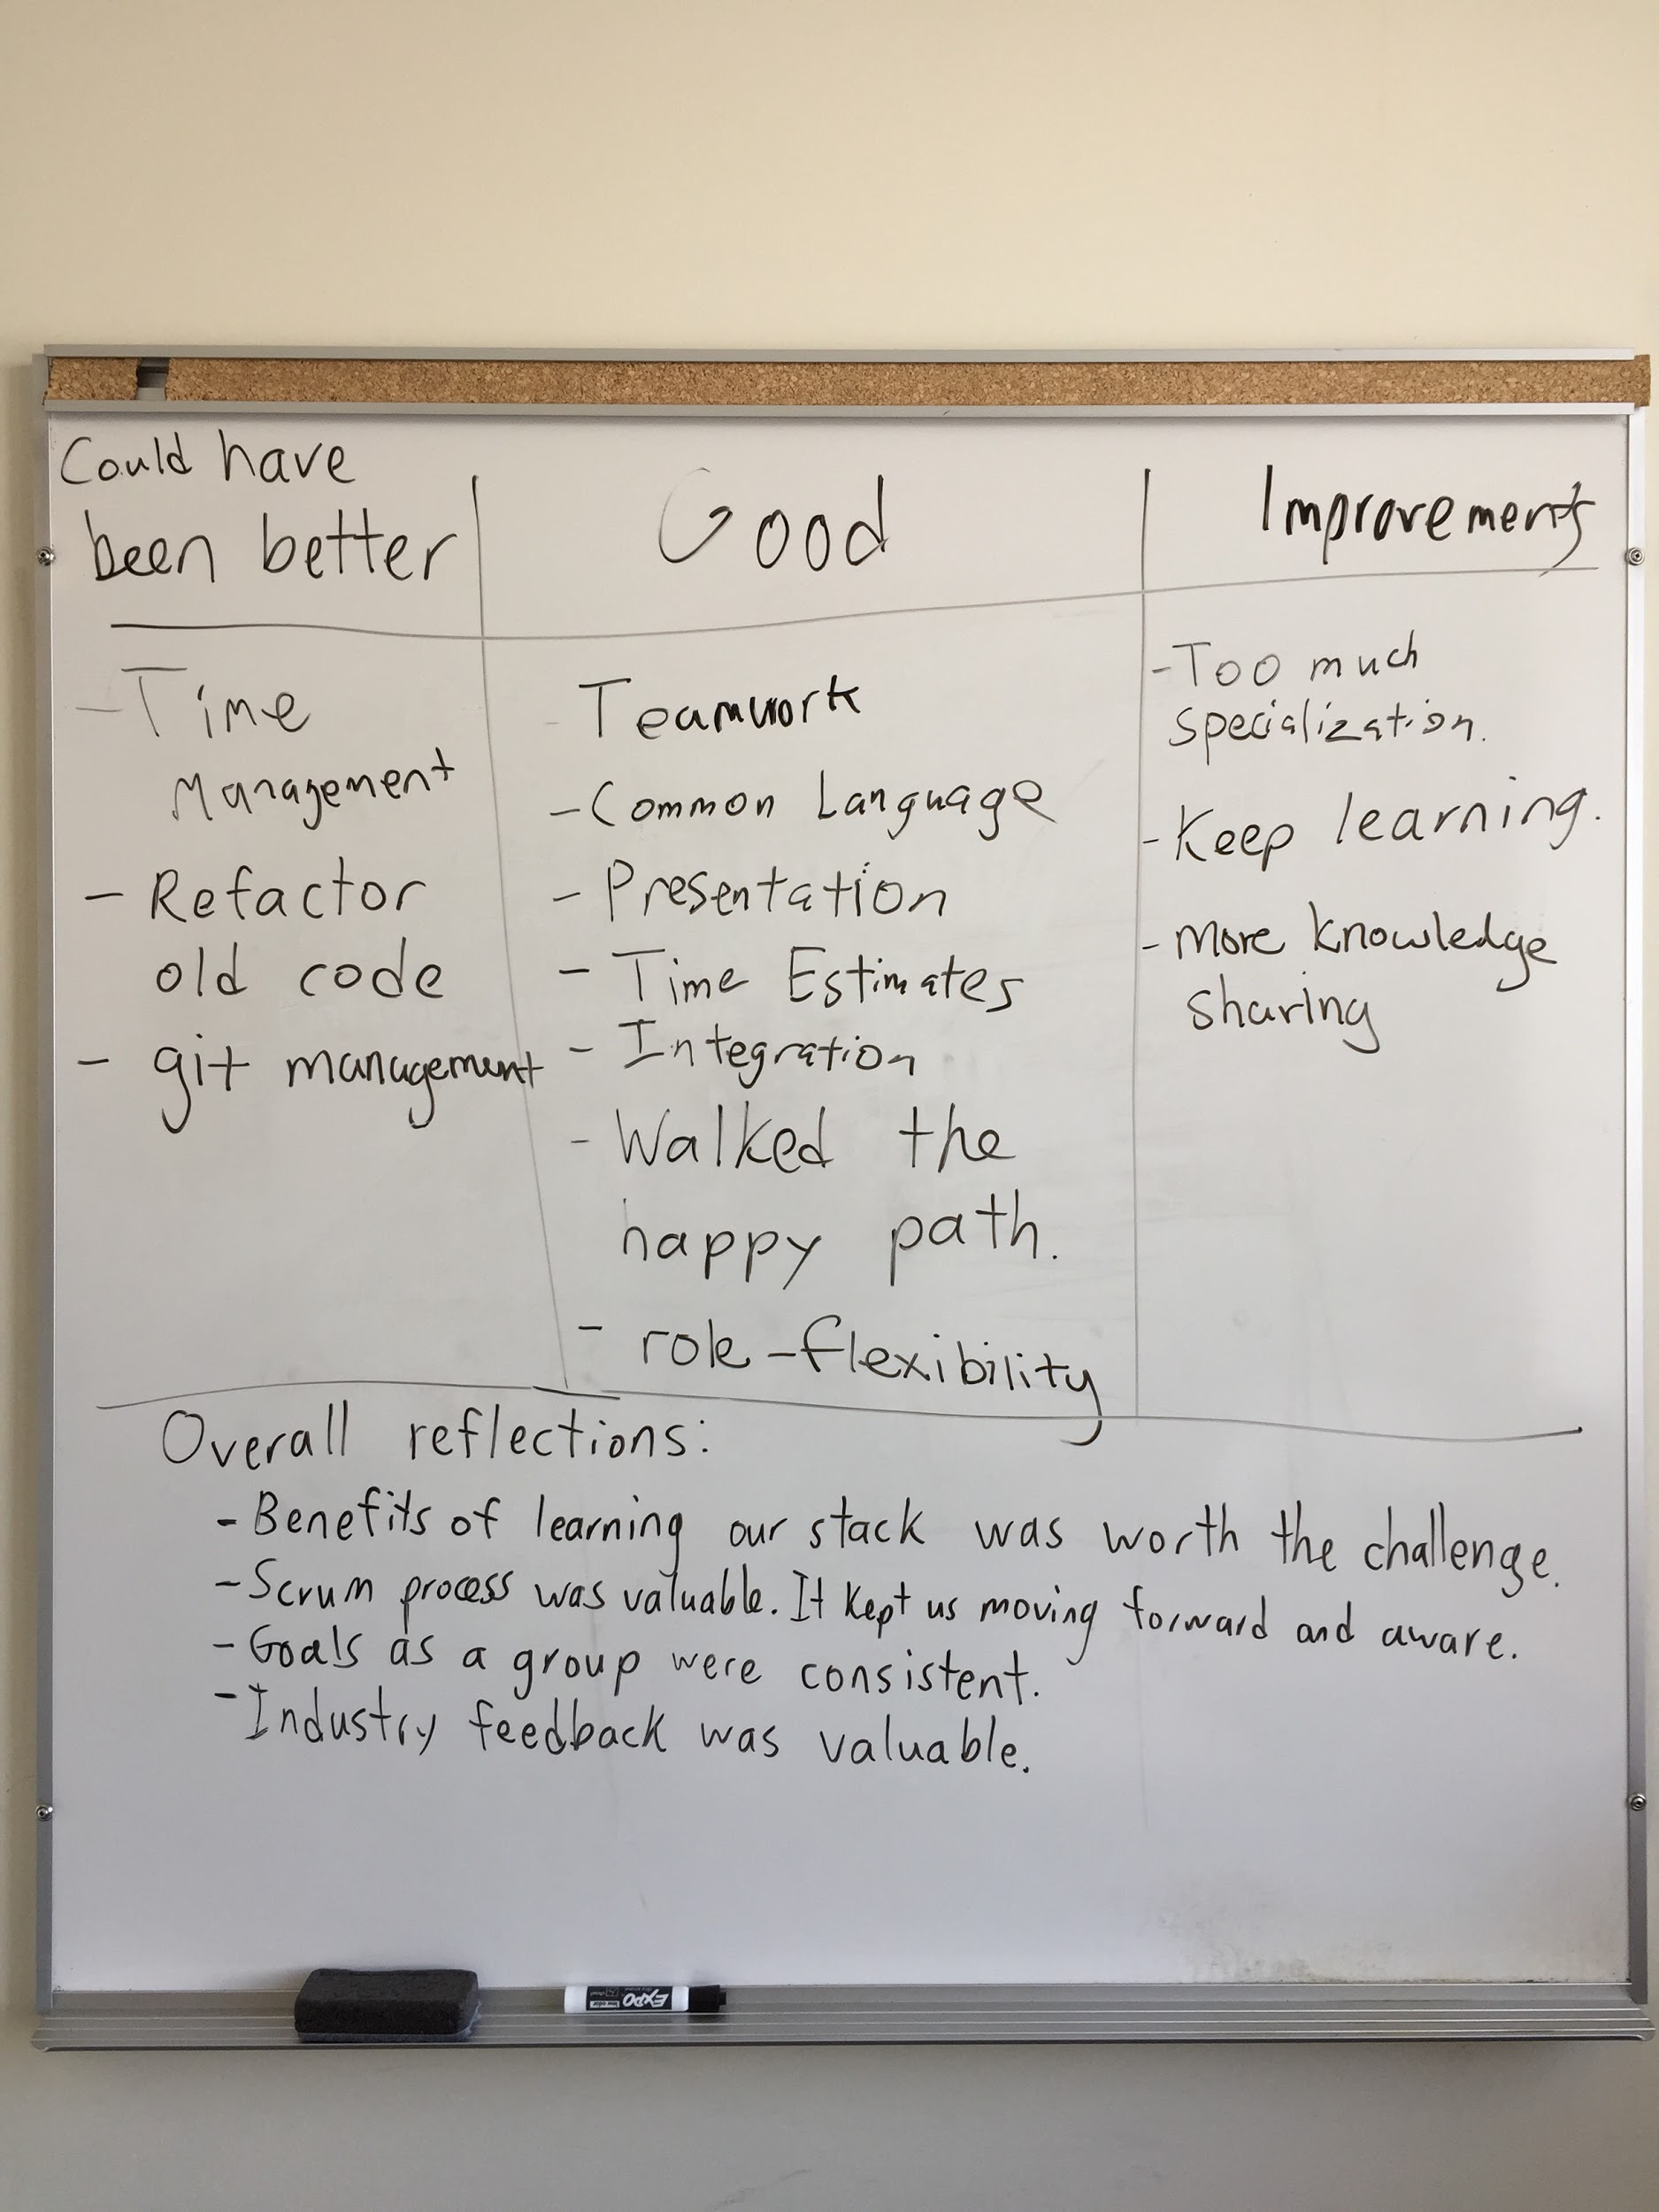

Plans:

* Sprint 4 plans have yet to be made.

**Burndown for Spring 3 on 2018/04/09:**

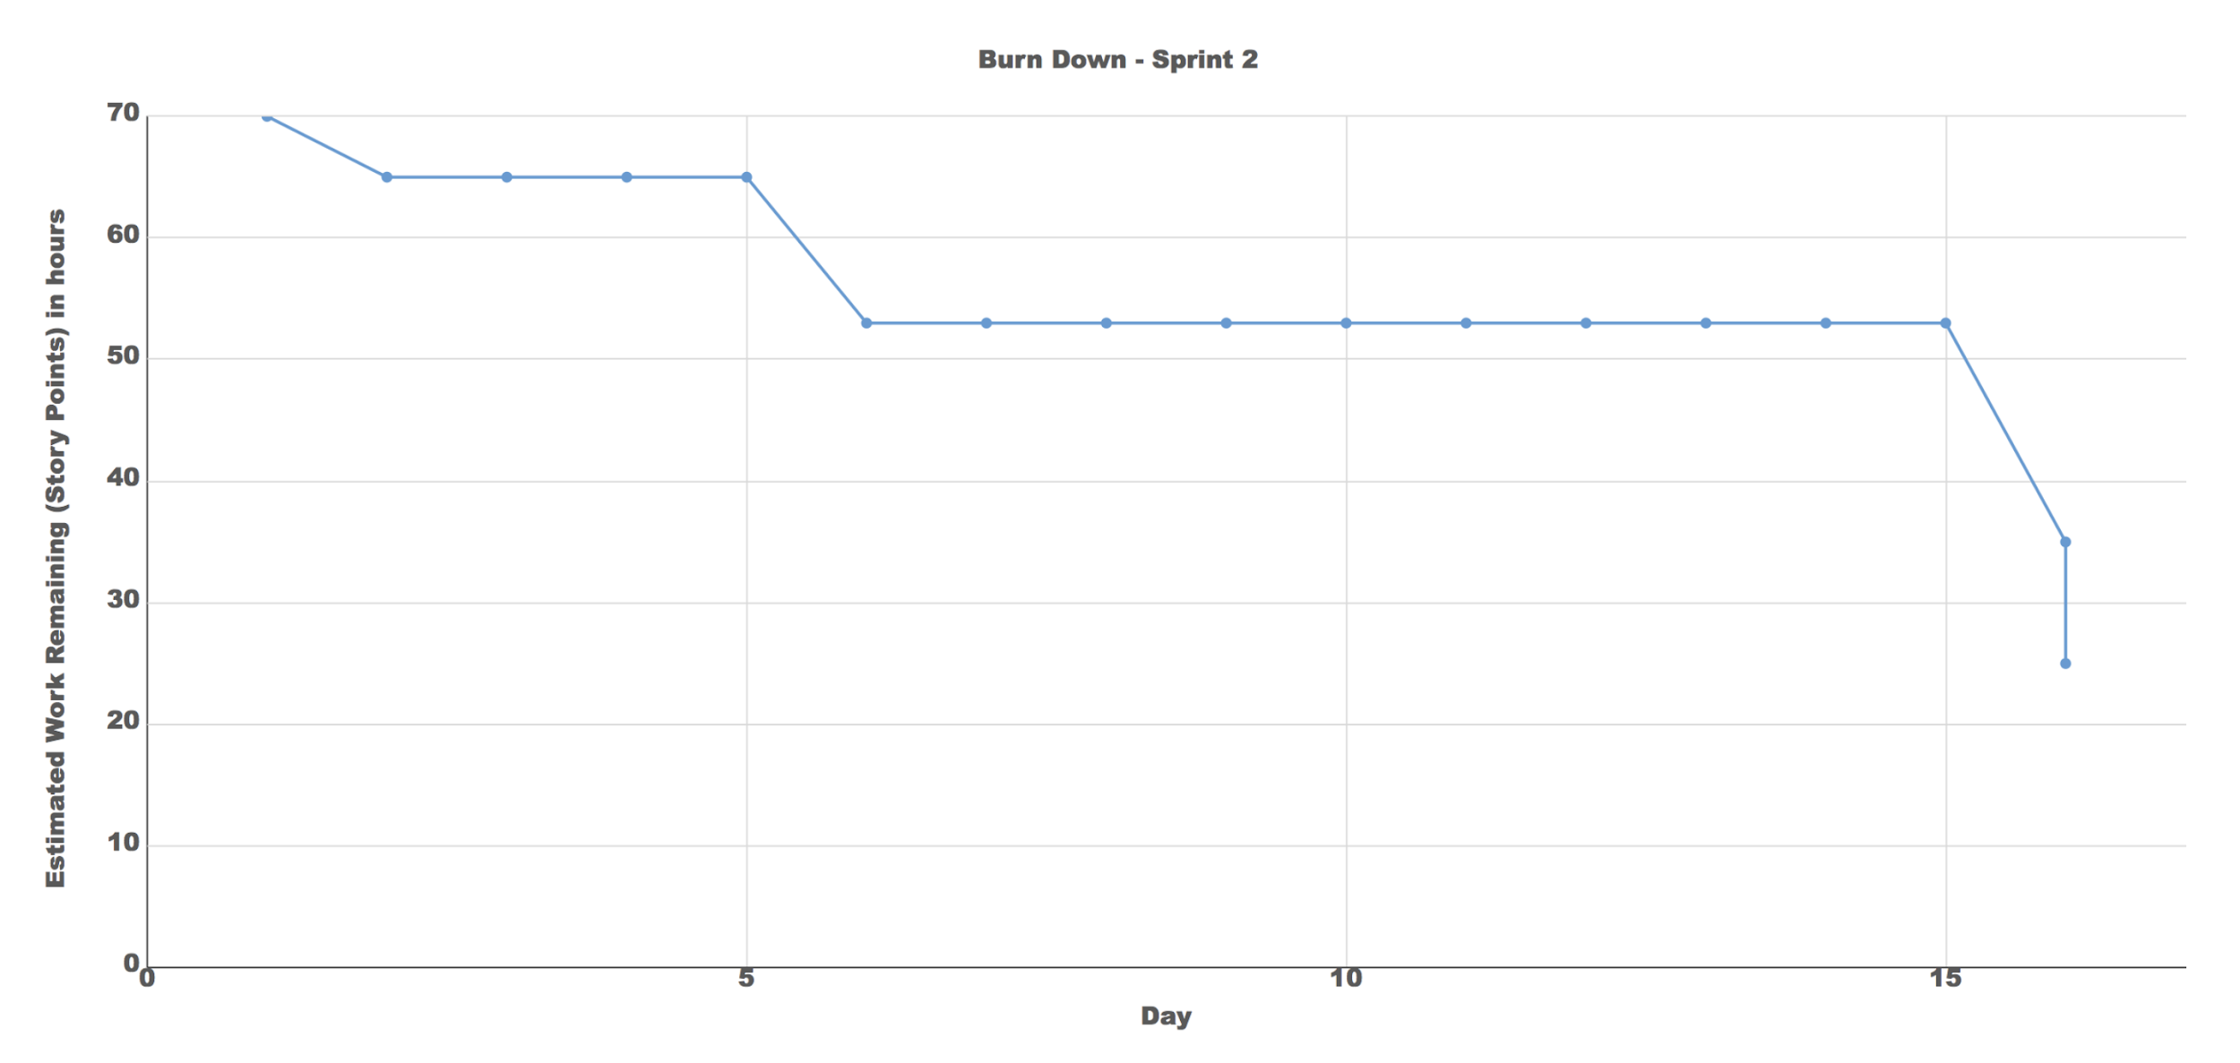

**Sprint 3 backlog on 2018/04/09:**

